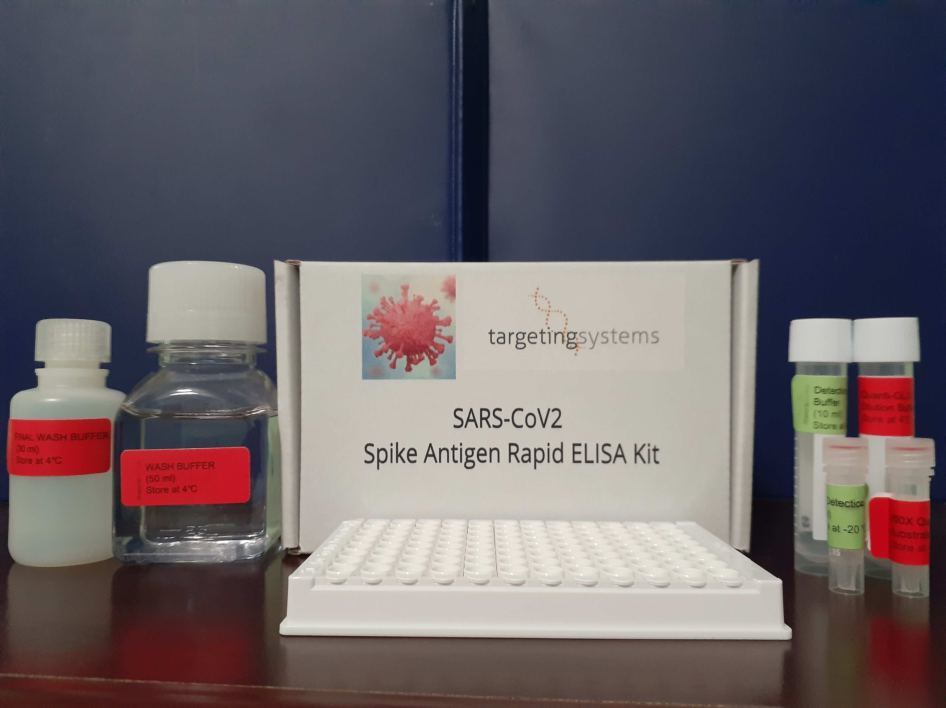

SARS-CoV2 Spike protein RAPID ELISA KIT

FOR RESEARCH USE ONLY- NOT FDA APPROVED
Size -96 tests
Sample: 50- 100 ul
Detection: Bioluminescence
Sensitivity- 0.1 pg/ml
Standard curve range 0. 1 pg/ml to 1 ug/ml
Instrument required: Microplate luminometer
Assay Time: 60 mins

Concentration of Spike Protein

Catalog # SPK-RELISA-01, $650
Enquire for a bulk purchase

KIT COMPONENTS:
Warning: Do not use any reagents where damage to the packaging has occurred.
The kit contains the following reagents:
- Anti-SCOV-2-Spike protein antibody (Capture antibody) COATED MICROTITER Plate with STRIPS Strip holder in a resealable foil pouch, containing 96 polystyrene microtiter wells coated with SCoV-2 antigen in each well. Stable at 2-8°C until the expiration date.
- SCOV-2 Spike protein antigen POSITIVE CONTROL: One vial, 50 μL. Positive Control sample containing recombinant spike protein. The Positive Control will aid in monitoring the integrity of the kit. Stable at 2-8°C until the expiration date.
- SAMPLE DILUTION BUFFER FOR SCOV-2: Two bottles, 25 mL each, ready to use. Stable at 2-8°C until the expiration date.
- 100X Detect ion Probe: One vial, 100 μL, a proprietary luciferase- spike antigen binding protein. Stable at 2-8°C until the expiration date.
- Detection Probe Dilution Buffer: One bottle, 30 mL. This contains the diluent solution for the 100X Conjugate in a Tris-based buffer with 0.01% Thimerosal as a preservative. The 100X detection probe is diluted directly into this solution. The 100X detection probe should only be diluted into this solution immediately prior to use.
MATERIALS REQUIRED BUT NOT SUPPLIED WITH THE KIT
- Microplate Luminometer
- Single- and multichannel pipettors
- Polypropylene tubes or 96 well dilution plates
- Parafilm or plastic plate cover Timer

WARNINGS AND PRECAUTIONS
- For in vitro diagnostic use under Emergency Use Authorization (EUA) only. A thorough understanding of this package insert is necessary for the successful use of the product. Reliable results will only be obtained by using precise laboratory techniques and accurately following the package insert.
- This test has not been FDA cleared or approved;

TECHNICAL MANUAL

Introduction:
The spike (S) glycoprotein of coronaviruses contains protrusions that will only bind to certain receptors on the host cell. Known receptors bind S1 are ACE2, angiotensin-converting enzyme 2; DPP4, dipeptidyl peptidase-4; APN, aminopeptidase N; CEACAM, carcinoembryonic antigen-related cell adhesion molecule 1; Sia, sialic acid; O-ac Sia, O-acetylated sialic acid. The spike is essential for both host specificity and viral infectivity. The term 'peplomer' is typically used to refer to a grouping of heterologous proteins on the virus surface that function together. The spike (S) glycoprotein of coronaviruses is known to be essential in the binding of the virus to the host cell at the advent of the infection process. It's been reported that 2019-nCoV can infect the human respiratory epithelial cells through interaction with the human ACE2 receptor. The spike protein is a large type I transmembrane protein containing two subunits, S1 and S2. S1 mainly contains a receptor binding domain (S1), which is responsible for recognizing the cell surface receptor. S2 contains basic elements needed for the membrane fusion. The S protein plays key parts in the induction of neutralizing-antibody and T-cell responses, as well as protective immunity. The main functions for the Spike protein are summarized as: Mediate receptor binding and membrane fusion; Defines the range of the hosts and specificity of the virus; Main component to bind with the neutralizing antibody; Key target for vaccine design; Can be transmitted between different hosts through gene recombination or mutation of the receptor binding domain (S1), leading to a higher mortality rate.
Principle
This assay employs the quantitative sandwich enzyme immunoassay technique. A monoclonal antibody specific for Spike Protein has been pre-coated onto a microplate. Standards and samples are pipetted into the wells and any Spike S1 Protein present is bound by the immobilized antibody. Following incubation unbound samples are removed during a wash step, and then a patented detection probe consisting of the ACE-2 receptor genetically fused to an enhanced luciferase reporter is added to the wells and binds to the combination of capture antibody-Spike Protein in sample. Following a wash step to remove any unbound combination, and luciferase assay reagent is added to the wells and the luciferase activity measured immediately using a microplate luminometer. The luciferase assay regaent is prepared by diluting the 100X luciferase substrate using the assay dilution buffer. The total duration of this assay is only 35 mins and sensitivity is 1 pg/ml

Materials Provided:
Part | Size | Storage of opened/Recon
Antibody Coated Plate | 8 x 12 cm | Return unused wells to the foil pouch containing the desiccant pack and store at ≤ 2-8 °C. Reseal along entire edge of zip-seal.
Standard SARS-CoV2 recombinant spike protein (S1 plus S2 plus ECD) Lyophilized | ug/50ul | Aliquot and store at ≤ -20 °C in a manual defrost freezer.* Avoid repeated freeze-thaw cycles.
100x Detection Probe | 500ul | May be stored for up to 6 month at -20°C.*
Detection Probe Dilution Buffer | 5 ml | May be stored for up to 6 month at 2-8°C.*
100X QuantiGLO Substrate | 100 ul | May be stored for up to 6 month at -20 °C.*
QuantiGLO Substrate Dilution Buffer | 10 mL | May be stored for up to 6 month at 2-8 °C.*
Wash Buffer | 50 mL
QuantiGLO substrate Dilution Buffer | 10 mL
Final Wash Buffer | 30mL
Plate Sealers | 2 extra sealers

Sample Collection And Storage
1. Cell Culture Supernates:
Remove particulates by centrifugation and assay immediately or aliquot and store samples at -20°C or lower temperature. Avoid repeated freeze-thaw cycles. If the use of original supernate sample or low dilution (<5 fold) are necessary due to the expected low concentration of antigen supernates need be adjust to neutral pH condition before assay.
2. Serum:
Use a serum separator tube and allow samples to clot for 30 minutes before centrifugation for 10 minutes at 1000x g, and detect; or aliquot and store samples at -20°C to -70°C (Stored at 2-8°C if tested within 24 hours). Avoid freeze/thaw cycles.
3. Plasma Collect plasma using EDTA or heparin as an anticoagulant. Centrifuge for 15 minutes at 1000x g within 30 minutes of collection, and detect; or aliquot and store samples at -20°C to -70°C (Stored at 2-8°C if tested within 24 hours). Avoid freeze / thaw cycles.
4. Avoid hemolytic and hyperlipidemia sample for Serum and Plasma.
5. Dilution:
Dilute samples at the appropriate multiple (recommend to do pre-test to determine the dilution factor).
Precautions
- FOR RESEARCH USE ONLY. NOT FOR USE IN DIAGNOSTIC PROCEDURES.
- Any variation in diluent, operator, pipetting technique, washing technique, incubation time or temperature, and kit age can cause variation in binding.
- Variations in sample collection, processing, and storage may cause sample value differences.
- Reagents may be harmful, if ingested, rinse it with an excess amount of tap water.
- Store kit contents at recommended temperature
- Adequate mixing is very important for good result. Use a mini-vortexer at the
lowest frequency.
- Mix the sample and all components in the kits adequately, and use clean plastic
container to prepare all of the diluent.
- Both the sample and standard should be assayed in duplicate, and the
sequence of the regents should be added consistently.
- Reuse of dissolved standard is not recommended.
- The kit should not be used beyond the expiration date on the kit label.
- The kit should be away from light when it is stored or incubated.
- To reduce the likelihood of blood-borne transmission of infectious agents, handle all serum, plasma and other biological fluids in accordance with NCCLS
regulations.
- To avoid cross contamination, please use disposable pipette tips.
- Please prepare all the kit components according to the Specification. If the kits
will be used several times, please seal the rest strips and preserve with
desiccants. Do use up within 2 months.

Experimental Materials
1. Microplate Luminometer(measuring luminescence at 482 nm (any standard lunometer)
2. Pipettes and pipette tips:0.5-10, 2-20, 20-200, 200-1000 μL. 3. Microplate washer, Squirt bottle.
4. Micro-oscillator.
5. Deionized or double distilled water, graduated cylinder.
6. Polypropylene Test tubes for dilution.
Reagent Preparation
- Bring all reagents to room temperature before use. If crystals have formed in the concentrate, Bring the reagent to room temperature and mix gently until the crystals have completely dissolve.
- Standard: Add Standard/Sample Diluent(R1) 0.5mL into freeze-dried standard, sit for a minimum of 15 minutes with gentle agitation prior to making dilutions (10000 pg/mL), Prepare EP tubes containing Standard/Sample Diluent(R1), and produce a dilution series according to the picture shown below (recommended concentration for standard curve: 10000, 5000, 2500, 1250, 625, 312, 156, 0 pg/mL). Redissolved standard solution (10000pg/mL), aliquot and store at -20°C— -70°C.

Wash Method
Aspirate each well and wash, repeating the process two times for a total of three washes. Wash by filling each well with Wash Buffer(300ul) using a squirt bottle, manifold dispenser, or autowasher. Complete removal of liquid at each step is essential to good performance. After the last wash, remove any remaining Wash Buffer by aspirating or decanting. Invert the plate and blot it against clean paper towels.
Assay Procedure
1. Remove excess microplate strips from the plate frame, return them to the foil pouch containing the desiccant pack, and reseal.
2. Add 100 μL Standard(positive control) or diluted samples or sample diluent (negative control) to each well
4. Cover with the adhesive strip provided. Incubate for 30 mins at RT
5. Wash 2 times with 300 ul Wash Buffer followed by final wash with 300 ul substrate dilution buffer.
6. Aspirate final wash and add 100 ul of QuantGLO assay reagent prepared as described below to each well and read immediately in a microplate luminometer integrating for 3 or5 seconds per well
NOTE: . Prepare the QuantiGLO luciferase assay reagent 15 minutes early before use by diluting the 100X QuantiGLO substrate with the appropriate amount of substrate dilution buffer
Calculations Of Results
1. Average the duplicate readings for each standard, control and sample, and subtract the average zero standard optical density (O.D.).
2. Create a standard curve by reducing the data using computer software capable of generating a log/log curve-fit. As an alternative, construct a standard curve by plotting the mean absorbance for each standard on the y-axis against the concentration on the x-axis and draw a best fit curve through the points on a log/log graph. The data may be linearized by plotting the log of the Spike S1 Protein concentrations versus the log of the luciferase activity on a linear scale, and the best fit line can be determined by regression analysis.
3. If samples have been diluted, the concentration read from the standard curve must be multiplied by the dilution factor.
Specificity
This assay recognizes both recombinant and natural Spike S1 Protein.

